

PROJECT TITLE:

**Market Basket Analysis**

TEAM MEMBERS

ARUN PANDI

**INTRODUCTION:**

In the rapidly evolving landscape of retail, the strategic utilization of data-driven insights is not just advantageous; it's imperative for staying competitive and meeting the ever-shifting expectations of customers. Our design thinking process, meticulously crafted and executed, involves a comprehensive approach to retail analytics, leveraging the potent Apriori algorithm for association rule mining. This intricate framework navigates through the complexities of retail data, from its inception to the extraction of actionable business recommendations, ushering in a new era of strategic decision-making.

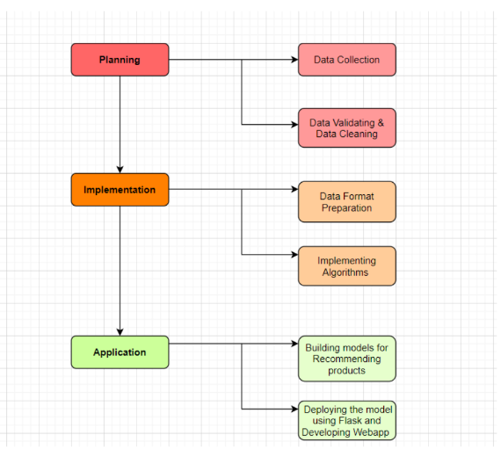

**1. Data Source Selection**

* **Kaggle Selection**

Our journey commences with a purposeful selection of a Kaggle dataset, where the emphasis lies on aligning the dataset intricacies with the dynamic nature of the retail sector. This deliberate selection ensures that the dataset serves as a robust foundation for our analytical endeavors.

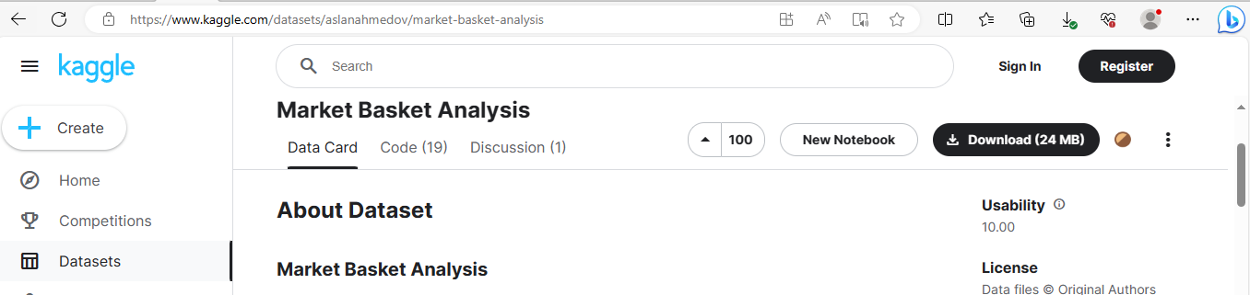

* **Representative Timeframe**

Ensuring the relevance of the data involves capturing a representative timeframe of customer transactions. This strategic decision ensures that our analyses are not only insightful but also reflective of the temporal dynamics inherent in the retail business.

* CSV Foundation

The selected dataset, meticulously curated and formatted in CSV, serves as the bedrock for our subsequent analytical insights. This choice of format facilitates seamless integration into our sophisticated analytical framework.

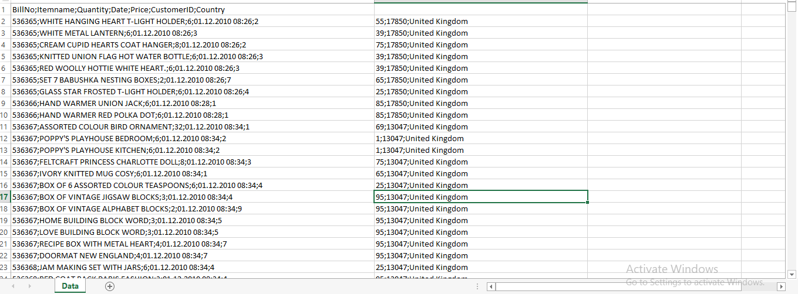

**2. Data Preprocessing**

* **Thorough Cleaning and Formatting**

Data preprocessing takes center stage in our approach. We meticulously address missing values, outliers, and inconsistencies, ensuring the accuracy and reliability of our subsequent analyses. This phase sets the stage for robust and meaningful insights.

* **Transactional Format Transformation**

The transformational phase is critical, where we apply advanced techniques to convert raw data into a transactional format. This transformation is a prerequisite for the effective application of the Apriori algorithm for association analysis.

* **Categorical Variable Encoding**

Handling categorical variables with precision and addressing data sparsity through advanced encoding methods contribute to the refinement of our dataset. This meticulous approach ensures that the subsequent analyses are not only accurate but also comprehensive.

**3. Association Analysis (Apriori Algorithm)**

* **Robust Mining Technique**

At the core of our project lies the implementation of the Apriori algorithm, a robust technique for association rule mining. This powerful algorithm uncovers intricate relationships within the dataset, revealing patterns that are crucial for understanding customer behavior and preferences.

* **Threshold Setting**

Setting the minimum support threshold is a pivotal decision-making process in our analytical journey. This decision requires a delicate balance between capturing meaningful patterns and avoiding noise, highlighting the sophistication of our approach.

* **Fine-tuned Parameters**

The adjustment of parameters such as support, confidence, and lift is done with meticulous care. This fine-tuning process ensures that the generated rules provide deep insights into customer behavior through frequent itemsets, offering a nuanced understanding.

**4. Insights Generation**

* **Interpretation Phase**

Transitioning from raw associations to actionable insights marks the interpretation phase. Each association rule is meticulously explored, ensuring that the derived insights are not only statistically significant but also practically relevant in the context of the retail business.

* **Statistical Significance and Practical Relevance**

Our insights go beyond mere statistical significance; they are crafted to ensure practical relevance. This approach ensures that the generated insights are not just interesting observations but actionable intelligence that can drive real-world business decisions.

**5. Visualization**

* **Effective Communication through Visualization**

As complex patterns emerge, effective communication becomes indispensable. We employ advanced visualization techniques, including network graphs and Scatterplots, to illustrate connections between products. These visual representations aid in the rapid comprehension of intricate patterns by diverse stakeholders.

* **Tailored Representations**

Visualizations are not one-size-fits-all. We tailor our visual representations to the audience, ensuring that the communication of complex patterns is effective and accessible to all stakeholders. This tailored approach enhances the understanding and utilization of insights.

**6. Business Recommendations**

* **Actionable Strategies**

The culmination of our analytical journey involves extracting actionable recommendations aligned seamlessly with the strategic goals of the retail business. Our insights go beyond being mere observations; they are actionable strategies seamlessly integrated into the fabric of business operations.

* **Product Bundling for Promotions**

Insights derived from Apriori, such as strong associations between products, pave the way for concrete recommendations. This may involve strategic product bundling for targeted promotions, a proven strategy in influencing customer behavior.

* **Optimized Inventory Management**

Recommendations extend to optimizing inventory management based on purchasing patterns. This strategic approach ensures that stock levels align dynamically with customer demand, enhancing operational efficiency.

* **Tailored Pricing and Marketing Campaigns**

Our strategies encompass tailored pricing and marketing campaigns, where insights from association analysis guide the formulation of approaches that resonate with customers. This tailored approach ensures that marketing efforts are not only impactful but also cost-effective.

**CONCLUSION:**

Our approach goes beyond conventional data analysis; it empowers the retail business with actionable intelligence, driving strategic decision-making and enhancing customer-centric operations. Through this extensive and meticulous process, we not only uncover patterns but translate them into tangible strategies that propel the business forward in the highly competitive and dynamic retail landscape.